PS

Lab sheet 03

IT24102097

Safran S.M

08/20/2025

1. 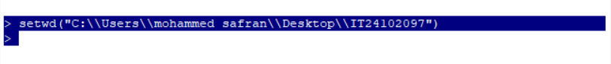
2. A screen shot of a number

   Description automatically generated
3. A screenshot of a graph

   Description automatically generated
4. 